What Is Artificial Intelligence?
Artificial Intelligence is a method of making a computer, a computer-controlled robot, or a software think intelligently like the human mind. AI is accomplished by studying the patterns of the human brain and by analyzing the cognitive process. The outcome of these studies develops intelligent software and systems.
DIFFERENCE BETWEEN AI AND I
S. No. | Feature | Artificial Intelligence | Human Intelligence
1 | Emergence | AI is an advancement made by human insights; its early improvement is credited to Norbert Weiner who theorized on criticism mechanisms. | On the other hand, human creatures are made with the intrinsic capacity to think, reason, review, etc.
2 | Nature | Artificial intelligence (AI) strives to build machines that can mimic human behavior and carry out human-like tasks. | Human intelligence seeks to adapt to new situations by combining a variety of cognitive processes.
3 | State | Machines are digital. | The human brain is analogous.
4 | Function | AI-powered machines rely on input of data and instructions. | Humans use their brains’ memory, processing power, and cognitive abilities.
5 | Pace/Rate of AI and human | As compared to people, computers can handle more data at a speedier rate. For occurrence, in the event that the human intellect can solve a math problem in 5 minutes, AI can solve 10 problems in a minute. | In terms of speed, humans cannot beat the speed of AI or machines.
6 | Learning ability | As machines are unable to reason abstractly or draw conclusions from the past. They can only acquire knowledge through information and frequent training, but they will never develop a human-specific thinking process. | Learning from various events and prior experiences is the foundation of human intelligence.
7 | Decision Making | AI is profoundly objective in choice making because it analyzes based on absolutely accumulated data. | Human choices may be affected by subjective components which are not based on figures alone.
8 | Perfection | AI frequently produces precise comes about because its capacities are based on a set of modified rules. | For human insights, there’s more often than not room for “human error” as certain subtle elements may be missed at one point or the other.
9 | Energy Consumption | The modern computer generally uses 2 watts of energy. | On the other hand, human brains uses about 25 watts
10 | Modification of AI and Human | AI takes much more time to adjust to unused changes. | Human insights can be adaptable in reaction to the changes in their environment. This makes individuals able to memorize and ace different skills.
11 | Versatility | AI can as it were perform fewer assignments at the same time as a framework can as it were learn duties one at a time. | The human judgment skills underpin multitasking as proven by differing and concurrent roles.
12 | Social Networking | AI has not aced the capacity to choose up on related social and enthusiastic cues. | On the other hand, as social creatures, people are much way better at social interaction since they can prepare theoretical data, have self-awareness, and are delicate to others’ feelings.
13 | Task | It does optimization of the system. It cannot be creative or innovative as humans can only think and machines cannot. | It is innovative or creative.

Artificial Intelligence is...
- “… the science and engineering of making intelligent machines” … “[where] intelligence is the computational part of the ability to achieve goals in the world” (original definition by John McCarthy who coined the term ‘Artificial Intelligence’ in 1955)
- “… making a machine behave in ways that would be called intelligent if a human were so behaving” (alternative definition by John McCarthy who coined the term ‘Artificial Intelligence’ in 1955)
- “… the science of making machines do things that would require intelligence if done by men” (definition offered by A.I. pioneer Marvin Minsky in 1968)
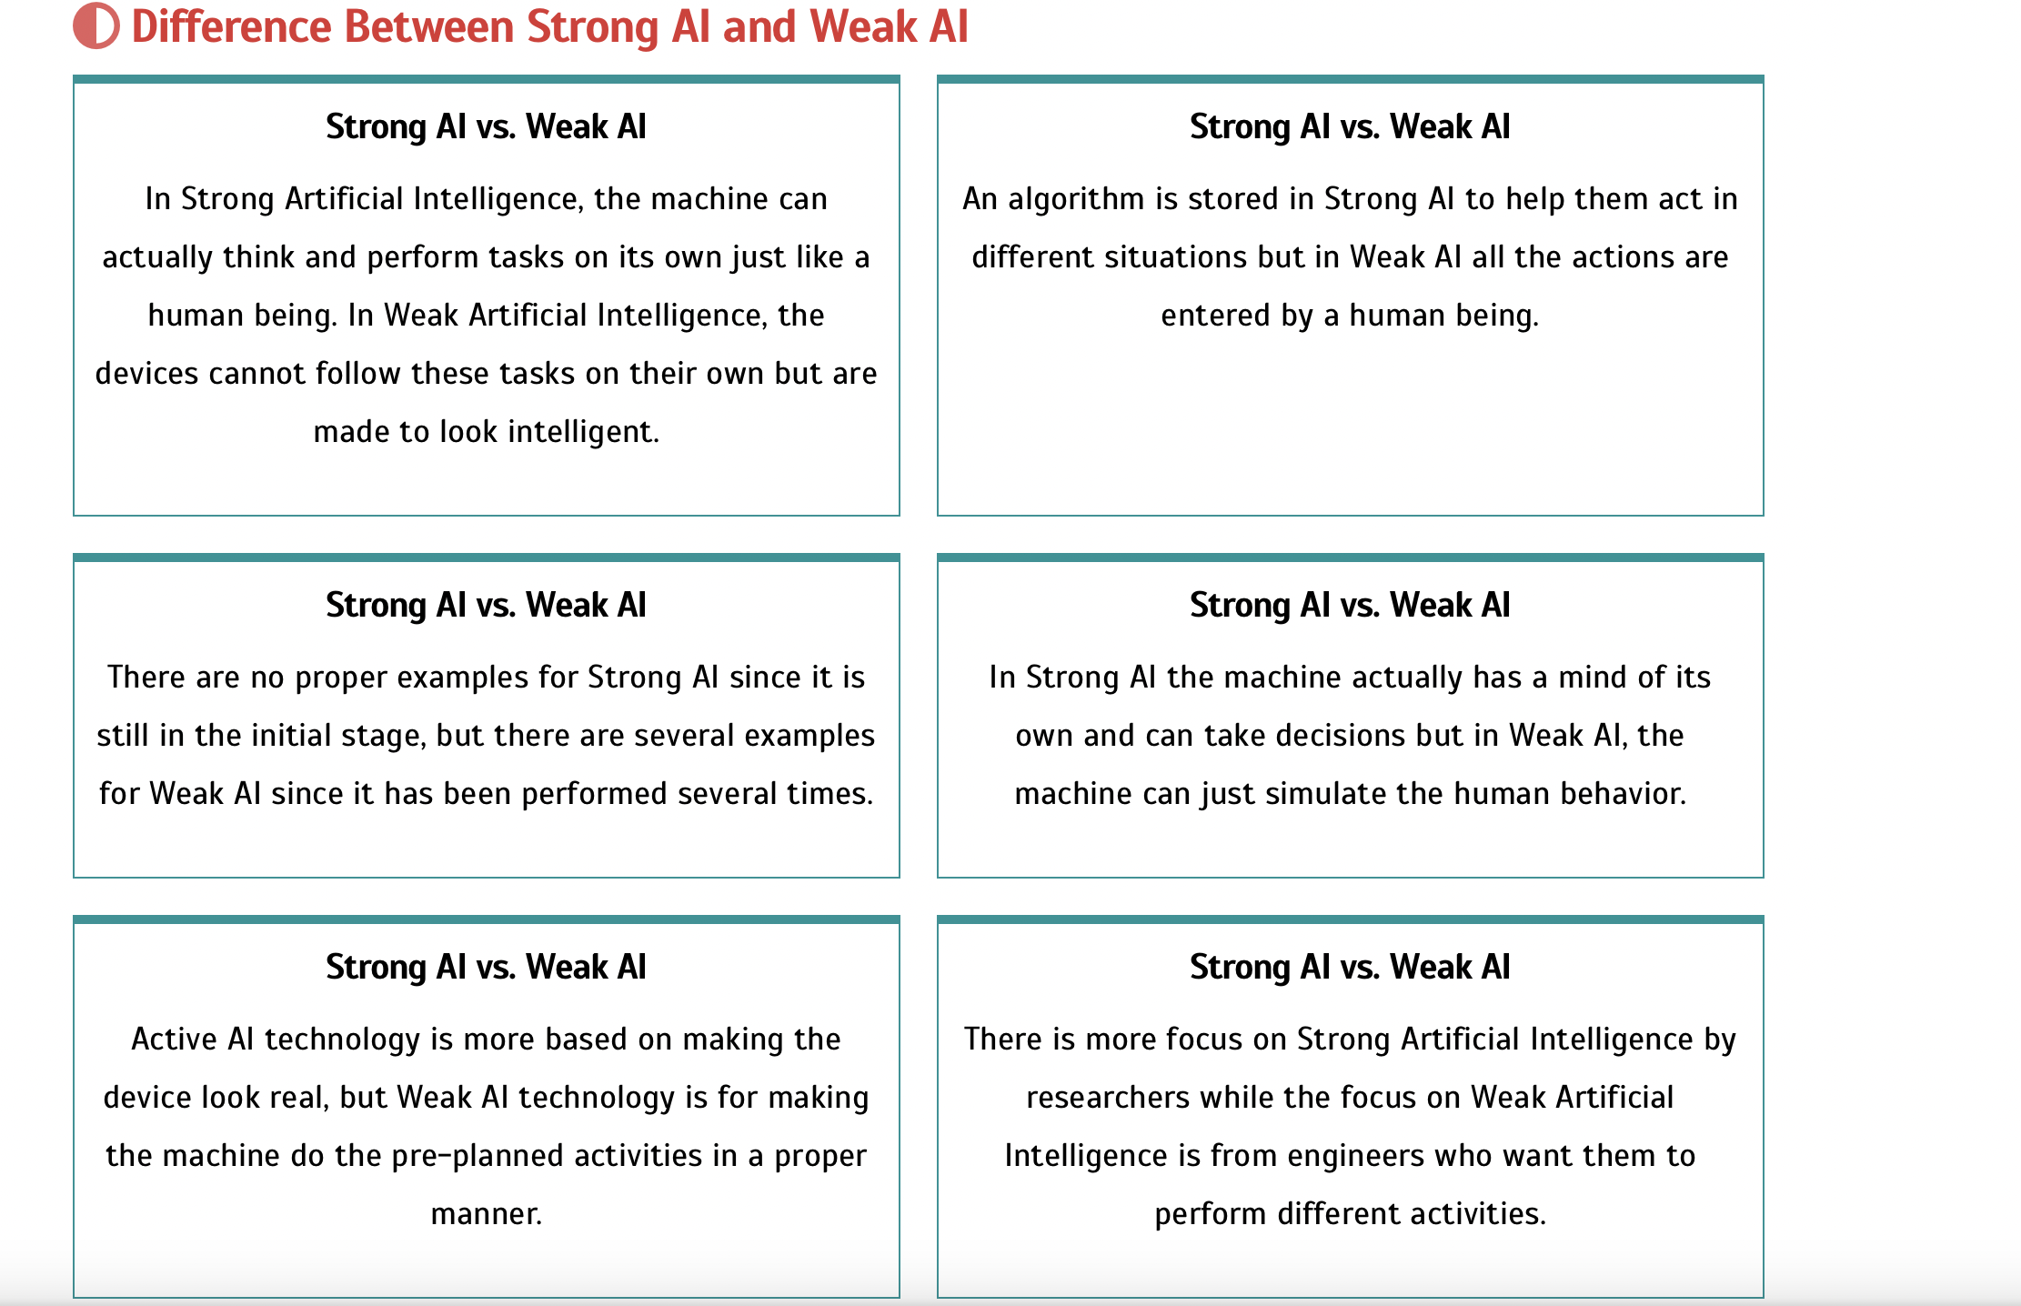
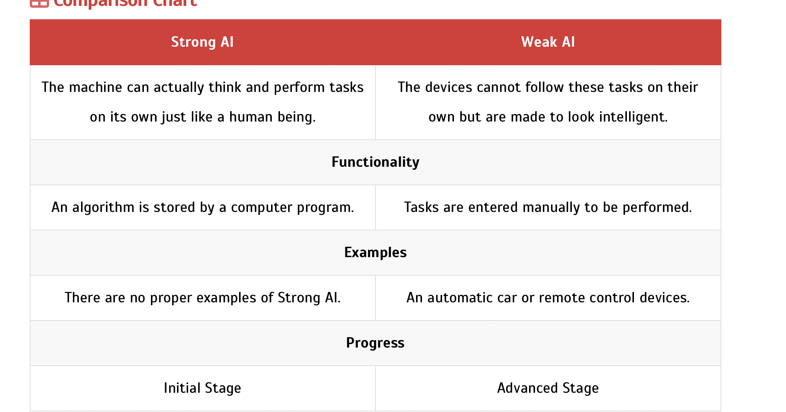
APPLICATION AREAS OF AI

1. AI in Astronomy
- Artificial Intelligence can be very useful to solve complex universe problems. AI technology can be helpful for understanding the universe such as how it works, origin, etc.
2. AI in Healthcare
- In the last, five to ten years, AI becoming more advantageous for the healthcare industry and going to have a significant impact on this industry.
- Healthcare Industries are applying AI to make a better and faster diagnosis than humans. AI can help doctors with diagnoses and can inform when patients are worsening so that medical help can reach to the patient before hospitalization.
3. AI in Gaming
- AI can be used for gaming purpose. The AI machines can play strategic games like chess, where the machine needs to think of a large number of possible places.
4. AI in Finance
- AI and finance industries are the best matches for each other. The finance industry is implementing automation, chatbot, adaptive intelligence, algorithm trading, and machine learning into financial processes.
5. AI in Data Security
- The security of data is crucial for every company and cyber-attacks are growing very rapidly in the digital world. AI can be used to make your data more safe and secure. Some examples such as AEG bot, AI2 Platform,are used to determine software bug and cyber-attacks in a better way.
6. AI in Social Media
- Social Media sites such as Facebook, Twitter, and Snapchat contain billions of user profiles, which need to be stored and managed in a very efficient way. AI can organize and manage massive amounts of data. AI can analyze lots of data to identify the latest trends, hashtag, and requirement of different users.
7. AI in Travel & Transport
- AI is becoming highly demanding for travel industries. AI is capable of doing various travel related works such as from making travel arrangement to suggesting the hotels, flights, and best routes to the customers. Travel industries are using AI-powered chatbots which can make human-like interaction with customers for better and fast response.
8. AI in Automotive Industry
- Some Automotive industries are using AI to provide virtual assistant to their user for better performance. Such as Tesla has introduced TeslaBot, an intelligent virtual assistant.
- Various Industries are currently working for developing self-driven cars which can make your journey more safe and secure.
9. AI in Robotics:
- Artificial Intelligence has a remarkable role in Robotics. Usually, general robots are programmed such that they can perform some repetitive task, but with the help of AI, we can create intelligent robots which can perform tasks with their own experiences without pre-programmed.
- Humanoid Robots are best examples for AI in robotics, recently the intelligent Humanoid robot named as Erica and Sophia has been developed which can talk and behave like humans.
10. AI in Entertainment
- We are currently using some AI based applications in our daily life with some entertainment services such as Netflix or Amazon. With the help of ML/AI algorithms, these services show the recommendations for programs or shows.
11. AI in Agriculture
- Agriculture is an area which requires various resources, labor, money, and time for best result. Now a day's agriculture is becoming digital, and AI is emerging in this field. Agriculture is applying AI as agriculture robotics, solid and crop monitoring, predictive analysis. AI in agriculture can be very helpful for farmers.

Conventional systems are rule based systems. Rules are clearly defined and implemented in the programming language as to how the system should function and behave in certain condition.
AI systems on the other hand are observation and learning based systems. They observe the surrounding ecosystem and the environment, the past data and how the system has responded in past to certain data. Based on this data, a pattern is established, rules are derived automatically and then systems follow these rules. The rules may evolve overtime based on the new data that system is constantly accumulating
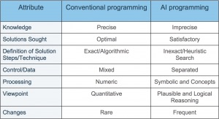

Turing Test in AI
In 1950, Alan Turing introduced a test to check whether a machine can think like a human or not, this test is known as the Turing Test. In this test, Turing proposed that the computer can be said to be an intelligent if it can mimic human response under specific conditions.
The Turing test is based on a party game "Imitation game," with some modifications. This game involves three players in which one player is Computer, another player is human responder, and the third player is a human Interrogator, who is isolated from other two players and his job is to find that which player is machine among two of them.
Consider, Player A is a computer, Player B is human, and Player C is an interrogator. Interrogator is aware that one of them is machine, but he needs to identify this on the basis of questions and their responses.
The conversation between all players is via keyboard and screen so the result would not depend on the machine's ability to convert words as speech.
The test result does not depend on each correct answer, but only how closely its responses like a human answer. The computer is permitted to do everything possible to force a wrong identification by the interrogator.
The questions and answers can be like:
Interrogator: Are you a computer?
PlayerA (Computer): No
Interrogator: Multiply two large numbers such as (256896489*456725896)
Player A: Long pause and give the wrong answer.
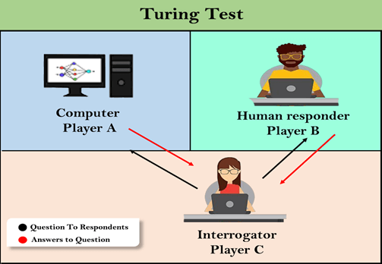
In this game, if an interrogator would not be able to identify which is a machine and which is human, then the computer passes the test successfully, and the machine is said to be intelligent and can think like a human.

The Major Branches of Artificial Intelligence
Here are the major branches of Artificial Intelligence;
- Experts Systems
- Robotics
- Machine Learning
- Neural Network
- Fuzzy Logic
- Natural Language Processing

Parameters | Informed Search | Uninformed Search
Known as | It is also known as Heuristic Search. | It is also known as Blind Search.
Using Knowledge | It uses knowledge for the searching process. | It doesn’t use knowledge for the searching process.
Performance | It finds a solution more quickly. | It finds solution slow as compared to an informed search.
Completion | It may or may not be complete. | It is always complete.
Cost Factor | Cost is low. | Cost is high.
Time | It consumes less time because of quick searching. | It consumes moderate time because of slow searching.
Direction | There is a direction given about the solution. | No suggestion is given regarding the solution in it.
Implementation | It is less lengthy while implemented. | It is more lengthy while implemented.
Efficiency | It is more efficient as efficiency takes into account cost and performance. The incurred cost is less and speed of finding solutions is quick. | It is comparatively less efficient as incurred cost is more and the speed of finding the Breadth-Firstsolution is slow.
Computational requirements | Computational requirements are lessened. | Comparatively higher computational requirements.
Size of search problems | Having a wide scope in terms of handling large search problems. | Solving a massive search task is challenging.
Examples of Algorithms | - Greedy Search  - A* Search  - AO* Search  - Hill Climbing Algorithm | - Depth First Search (DFS)  - Breadth First Search (BFS)  - Branch and Bound

BFS vs DFS
S. No. | Parameters | BFS | DFS
1 | Stands for | BFS stands for Breadth First Search. | DFS stands for Depth First Search.
2 | Data Structure | BFS(Breadth First Search) uses Queue data structure for finding the shortest path. | DFS(Depth First Search) uses Stack data structure.
3 | Definition | BFS is a traversal approach in which we first walk through all nodes on the same level before moving on to the next level. | DFS is also a traversal approach in which the traverse begins at the root node and proceeds through the nodes as far as possible until we reach the node with no unvisited nearby nodes.
4 | Technique | BFS can be used to find a single source shortest path in an unweighted graph because, in BFS, we reach a vertex with a minimum number of edges from a source vertex. | In DFS, we might traverse through more edges to reach a destination vertex from a source.
5 | Conceptual Difference | BFS builds the tree level by level. | DFS builds the tree sub-tree by sub-tree.
6 | Approach used | It works on the concept of FIFO (First In First Out). | It works on the concept of LIFO (Last In First Out).
7 | Suitable for | BFS is more suitable for searching vertices closer to the given source. | DFS is more suitable when there are solutions away from source.
8 | Suitable for Decision Treestheirwinning | BFS considers all neighbors first and therefore not suitable for decision-making trees used in games or puzzles. | DFS is more suitable for game or puzzle problems. We make a decision, and the then explore all paths through this decision. And if this decision leads to win situation, we stop.
9 | Time Complexity | The Time complexity of BFS is O(V + E) when Adjacency List is used and O(V^2) when Adjacency Matrix is used, where V stands for vertices and E stands for edges. | The Time complexity of DFS is also O(V + E) when Adjacency List is used and O(V^2) when Adjacency Matrix is used, where V stands for vertices and E stands for edges.
10 | Visiting of Siblings/ Children | Here, siblings are visited before the children. | Here, children are visited before the siblings.
11 | Removal of Traversed Nodes | Nodes that are traversed several times are deleted from the queue. | The visited nodes are added to the stack and then removed when there are no more nodes to visit.
12 | Backtracking | In BFS there is no concept of backtracking. | DFS algorithm is a recursive algorithm that uses the idea of backtracking
13 | Applications | BFS is used in various applications such as bipartite graphs, shortest paths, etc. | DFS is used in various applications such as acyclic graphs and topological order etc.
14 | Memory | BFS requires more memory. | DFS requires less memory.
15 | Optimality | BFS is optimal for finding the shortest path. | DFS is not optimal for finding the shortest path.
16 | Space complexity | In BFS, the space complexity is more critical as compared to time complexity. | DFS has lesser space complexity because at a time it needs to store only a single path from the root to the leaf node.
17 | Speed | BFS is slow as compared to DFS. | DFS is fast as compared to BFS.
18 | When to use? | When the target is close to the source, BFS performs better. | When the target is far from the source, DFS is preferable.

1. Breadth-first Search:
- Breadth-first search is the most common search strategy for traversing a tree or graph. This algorithm searches breadthwise in a tree or graph, so it is called breadth-first search.
- BFS algorithm starts searching from the root node of the tree and expands all successor node at the current level before moving to nodes of next level.
- The breadth-first search algorithm is an example of a general-graph search algorithm.
- Breadth-first search implemented using FIFO queue data structure.
Advantages:
- BFS will provide a solution if any solution exists.
- If there are more than one solutions for a given problem, then BFS will provide the minimal solution which requires the least number of steps.
Disadvantages:

- It requires lots of memory since each level of the tree must be saved into memory to expand the next level.
- BFS needs lots of time if the solution is far away from the root node.
Example:
In the below tree structure, we have shown the traversing of the tree using BFS algorithm from the root node S to goal node K. BFS search algorithm traverse in layers, so it will follow the path which is shown by the dotted arrow, and the traversed path will be:

- S---> A--->B---->C--->D---->G--->H--->E---->F---->I---->K
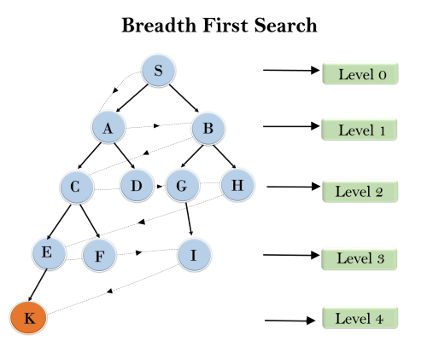
Time Complexity: Time Complexity of BFS algorithm can be obtained by the number of nodes traversed in BFS until the shallowest Node. Where the d= depth of shallowest solution and b is a node at every state.
T (b) = 1+b²+b³+.......+ b^{d}= O (b^{d})
Space Complexity: Space complexity of BFS algorithm is given by the Memory size of frontier which is O(b^{d}).
Completeness: BFS is complete, which means if the shallowest goal node is at some finite depth, then BFS will find a solution.
Optimality: BFS is optimal if path cost is a non-decreasing function of the depth of the node.
2. Depth-first Search
- Depth-first search isa recursive algorithm for traversing a tree or graph data structure.
- It is called the depth-first search because it starts from the root node and follows each path to its greatest depth node before moving to the next path.
- DFS uses a stack data structure for its implementation.
- The process of the DFS algorithm is similar to the BFS algorithm.
Note: Backtracking is an algorithm technique for finding all possible solutions using recursion.
Advantage:
- DFS requires very less memory as it only needs to store a stack of the nodes on the path from root node to the current node.
- It takes less time to reach to the goal node than BFS algorithm (if it traverses in the right path).
Disadvantage

- There is the possibility that many states keep re-occurring, and there is no guarantee of finding the solution.
- DFS algorithm goes for deep down searching and sometime it may go to the infinite loop.
Example:
In the below search tree, we have shown the flow of depth-first search, and it will follow the order as:
Root node--->Left node ----> right node.
It will start searching from root node S, and traverse A, then B, then D and E, after traversing E, it will backtrack the tree as E has no other successor and still goal node is not found. After backtracking it will traverse node C and then G, and here it will terminate as it found goal node.
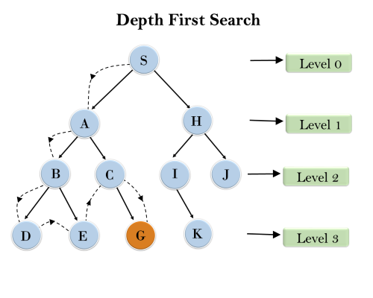
Completeness: DFS search algorithm is complete within finite state space as it will expand every node within a limited search tree.
Time Complexity: Time complexity of DFS will be equivalent to the node traversed by the algorithm. It is given by:

T(n)= 1+ n²+ n³ +.........+ n^{m}=O(n^{m})
Where, m= maximum depth of any node and this can be much larger than d (Shallowest solution depth)
Space Complexity: DFS algorithm needs to store only single path from the root node, hence space complexity of DFS is equivalent to the size of the fringe set, which is O(bm).

Optimal: DFS search algorithm is non-optimal, as it may generate a large number of steps or high cost to reach to the goal node.

Heuristics function: Heuristic is a function which is used in Informed Search, and it finds the most promising path. It takes the current state of the agent as its input and produces the estimation of how close agent is from the goal. The heuristic method, however, might not always give the best solution, but it guaranteed to find a good solution in reasonable time. Heuristic function estimates how close a state is to the goal. It is represented by h(n), and it calculates the cost of an optimal path between the pair of states. The value of the heuristic function is always positive.
Admissibility of the heuristic function is given as:

- h(n) <= h*(n)
Here h(n) is heuristic cost, and h*(n) is the estimated cost. Hence heuristic cost should be less than or equal to the estimated cost.
Pure Heuristic Search:
Pure heuristic search is the simplest form of heuristic search algorithms. It expands nodes based on their heuristic value h(n). It maintains two lists, OPEN and CLOSED list. In the CLOSED list, it places those nodes which have already expanded and in the OPEN list, it places nodes which have yet not been expanded.
On each iteration, each node n with the lowest heuristic value is expanded and generates all its successors and n is placed to the closed list. The algorithm continues unit a goal state is found.
In the informed search we will discuss two main algorithms which are given below:
- Best First Search Algorithm(Greedy search)
- A* Search Algorithm
1.) Best-first Search Algorithm (Greedy Search):
Greedy best-first search algorithm always selects the path which appears best at that moment. It is the combination of depth-first search and breadth-first search algorithms. It uses the heuristic function and search. Best-first search allows us to take the advantages of both algorithms. With the help of best-first search, at each step, we can choose the most promising node. In the best first search algorithm, we expand the node which is closest to the goal node and the closest cost is estimated by heuristic function, i.e.

- f(n)= g(n).
Were, h(n)= estimated cost from node n to the goal.
The greedy best first algorithm is implemented by the priority queue.
Best first search algorithm:
- Step 1: Place the starting node into the OPEN list.
- Step 2: If the OPEN list is empty, Stop and return failure.
- Step 3: Remove the node n, from the OPEN list which has the lowest value of h(n), and places it in the CLOSED list.
- Step 4: Expand the node n, and generate the successors of node n.
- Step 5: Check each successor of node n, and find whether any node is a goal node or not. If any successor node is goal node, then return success and terminate the search, else proceed to Step 6.
- Step 6: For each successor node, algorithm checks for evaluation function f(n), and then check if the node has been in either OPEN or CLOSED list. If the node has not been in both list, then add it to the OPEN list.
- Step 7: Return to Step 2.
Advantages:
- Best first search can switch between BFS and DFS by gaining the advantages of both the algorithms.
- This algorithm is more efficient than BFS and DFS algorithms.
Disadvantages:
- It can behave as an unguided depth-first search in the worst case scenario.
- It can get stuck in a loop as DFS.
- This algorithm is not optimal.
Example:
Consider the below search problem, and we will traverse it using greedy best-first search. At each iteration, each node is expanded using evaluation function f(n)=h(n) , which is given in the below table.
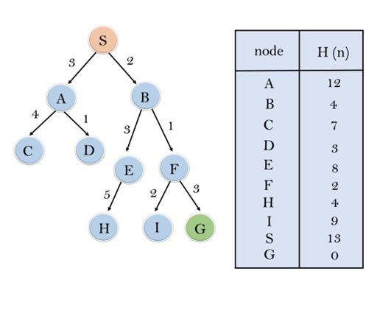
In this search example, we are using two lists which are OPEN and CLOSED Lists. Following are the iteration for traversing the above example.
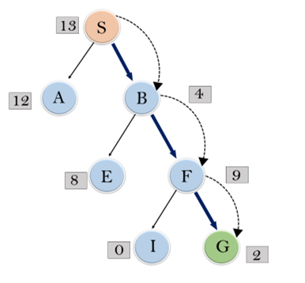
Expand the nodes of S and put in the CLOSED list
Initialization: Open [A, B], Closed [S]
Iteration 1: Open [A], Closed [S, B]
Iteration 2: Open [E, F, A], Closed [S, B]
: Open [E, A], Closed [S, B, F]

Iteration 3: Open [I, G, E, A], Closed [S, B, F]
: Open [I, E, A], Closed [S, B, F, G]
Hence the final solution path will be: S----> B----->F----> G
Time Complexity: The worst case time complexity of Greedy best first search is O(b^{m}).

Space Complexity: The worst case space complexity of Greedy best first search is O(b^{m}). Where, m is the maximum depth of the search space.
Complete: Greedy best-first search is also incomplete, even if the given state space is finite.
Optimal: Greedy best first search algorithm is not optimal.

Hill Climbing Algorithm in Artificial Intelligence
- Hill climbing algorithm is a local search algorithm which continuously moves in the direction of increasing elevation/value to find the peak of the mountain or best solution to the problem. It terminates when it reaches a peak value where no neighbor has a higher value.
- Hill climbing algorithm is a technique which is used for optimizing the mathematical problems. One of the widely discussed examples of Hill climbing algorithm is Traveling-salesman Problem in which we need to minimize the distance traveled by the salesman.
- It is also called greedy local search as it only looks to its good immediate neighbor state and not beyond that.
- A node of hill climbing algorithm has two components which are state and value.
- Hill Climbing is mostly used when a good heuristic is available.
- In this algorithm, we don't need to maintain and handle the search tree or graph as it only keeps a single current state.
Features of Hill Climbing:
Following are some main features of Hill Climbing Algorithm:
- Generate and Test variant: Hill Climbing is the variant of Generate and Test method. The Generate and Test method produce feedback which helps to decide which direction to move in the search space.
- Greedy approach: Hill-climbing algorithm search moves in the direction which optimizes the cost.
- No backtracking: It does not backtrack the search space, as it does not remember the previous states.
State-space Diagram for Hill Climbing:
The state-space landscape is a graphical representation of the hill-climbing algorithm which is showing a graph between various states of algorithm and Objective function/Cost.
On Y-axis we have taken the function which can be an objective function or cost function, and state-space on the x-axis. If the function on Y-axis is cost then, the goal of search is to find the global minimum and local minimum. If the function of Y-axis is Objective function, then the goal of the search is to find the global maximum and local maximum.
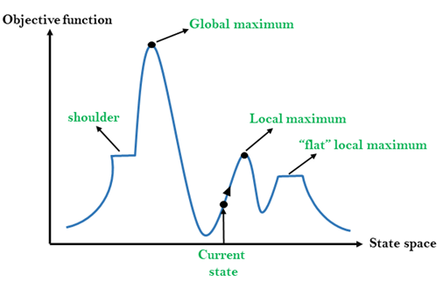
Different regions in the state space landscape:
Local Maximum: Local maximum is a state which is better than its neighbor states, but there is also another state which is higher than it.

Global Maximum: Global maximum is the best possible state of state space landscape. It has the highest value of objective function.
Current state: It is a state in a landscape diagram where an agent is currently present.
Flat local maximum: It is a flat space in the landscape where all the neighbor states of current states have the same value.
Shoulder: It is a plateau region which has an uphill edge.
Types of Hill Climbing Algorithm:
- Simple hill Climbing:
- Steepest-Ascent hill-climbing:
- Stochastic hill Climbing:
1. Simple Hill Climbing:
Simple hill climbing is the simplest way to implement a hill climbing algorithm. It only evaluates the neighbor node state at a time and selects the first one which optimizes current cost and set it as a current state. It only checks it's one successor state, and if it finds better than the current state, then move else be in the same state. This algorithm has the following features:
- Less time consuming
- Less optimal solution and the solution is not guaranteed
Algorithm for Simple Hill Climbing:
- Step 1: Evaluate the initial state, if it is goal state then return success and Stop.
- Step 2: Loop Until a solution is found or there is no new operator left to apply.
- Step 3: Select and apply an operator to the current state.
- Step 4: Check new state:
  - If it is goal state, then return success and quit.
  - Else if it is better than the current state then assign new state as a current state.
  - Else if not better than the current state, then return to step2.
- Step 5: Exit.
2. Steepest-Ascent hill climbing:
The steepest-Ascent algorithm is a variation of simple hill climbing algorithm. This algorithm examines all the neighboring nodes of the current state and selects one neighbor node which is closest to the goal state. This algorithm consumes more time as it searches for multiple neighbors
Algorithm for Steepest-Ascent hill climbing:
- Step 1: Evaluate the initial state, if it is goal state then return success and stop, else make current state as initial state.
- Step 2: Loop until a solution is found or the current state does not change.
  - Let SUCC be a state such that any successor of the current state will be better than it.
  - For each operator that applies to the current state:
    - Apply the new operator and generate a new state.
    - Evaluate the new state.
    - If it is goal state, then return it and quit, else compare it to the SUCC.
    - If it is better than SUCC, then set new state as SUCC.
    - If the SUCC is better than the current state, then set current state to SUCC.
- Step 5: Exit.
3. Stochastic hill climbing:
Stochastic hill climbing does not examine for all its neighbor before moving. Rather, this search algorithm selects one neighbor node at random and decides whether to choose it as a current state or examine another state.
Problems in Hill Climbing Algorithm:
1. Local Maximum: A local maximum is a peak state in the landscape which is better than each of its neighboring states, but there is another state also present which is higher than the local maximum.

Solution: Backtracking technique can be a solution of the local maximum in state space landscape. Create a list of the promising path so that the algorithm can backtrack the search space and explore other paths as well.
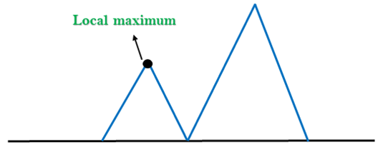
2. Plateau: A plateau is the flat area of the search space in which all the neighbor states of the current state contains the same value, because of this algorithm does not find any best direction to move. A hill-climbing search might be lost in the plateau area.
Solution: The solution for the plateau is to take big steps or very little steps while searching, to solve the problem. Randomly select a state which is far away from the current state so it is possible that the algorithm could find non-plateau region.
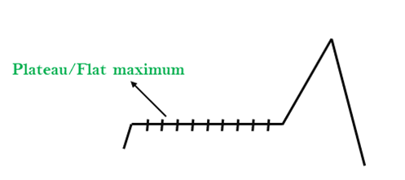
3. Ridges: A ridge is a special form of the local maximum. It has an area which is higher than its surrounding areas, but itself has a slope, and cannot be reached in a single move.
Solution: With the use of bidirectional search, or by moving in different directions, we can improve this problem.

RETREAT TO
AN ISLAND PARADISE

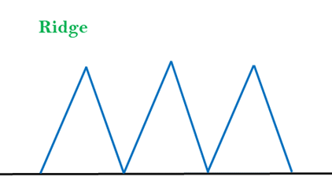
Simulated Annealing:
A hill-climbing algorithm which never makes a move towards a lower value guaranteed to be incomplete because it can get stuck on a local maximum. And if algorithm applies a random walk, by moving a successor, then it may complete but not efficient. Simulated Annealing is an algorithm which yields both efficiency and completeness.
In mechanical term Annealing is a process of hardening a metal or glass to a high temperature then cooling gradually, so this allows the metal to reach a low-energy crystalline state. The same process is used in simulated annealing in which the algorithm picks a random move, instead of picking the best move. If the random move improves the state, then it follows the same path. Otherwise, the algorithm follows the path which has a probability of less than 1 or it moves downhill and chooses another path.

